Set 4: Product Inventory Management
1. Bar Chart to Visualize Product Quantity
A bar chart is used to compare the quantity available for each product in the inventory. The product names are shown on the X-axis, and the quantity available is shown on the Y-axis.
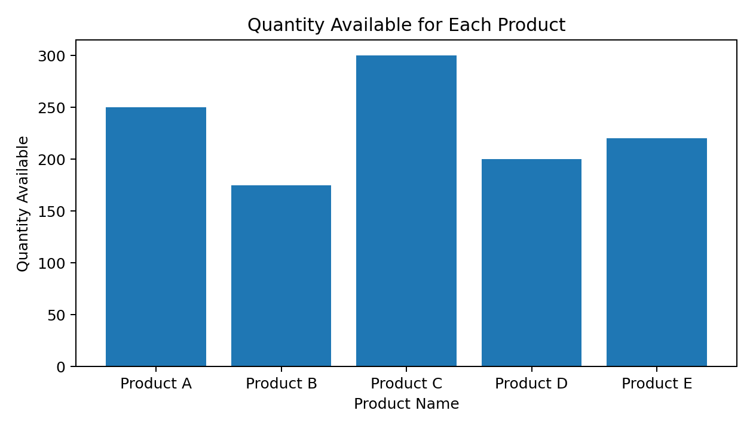
Observation: Product C has the highest quantity, with 300 units. Product B has the lowest quantity, with 175 units. Product A has 250 units, Product D has 200 units, and Product E has 220 units.
Conclusion: The bar chart makes it easy to compare stock levels and identify products that may need replenishment.

2. Stacked Bar Chart for Product Categories
A stacked bar chart displays quantities as segments within each product category. The given dataset contains only one quantity value for each product and does not provide separate categories or subcategory quantities. Therefore, the following example treats each product as one category and shows its available quantity as a single segment.
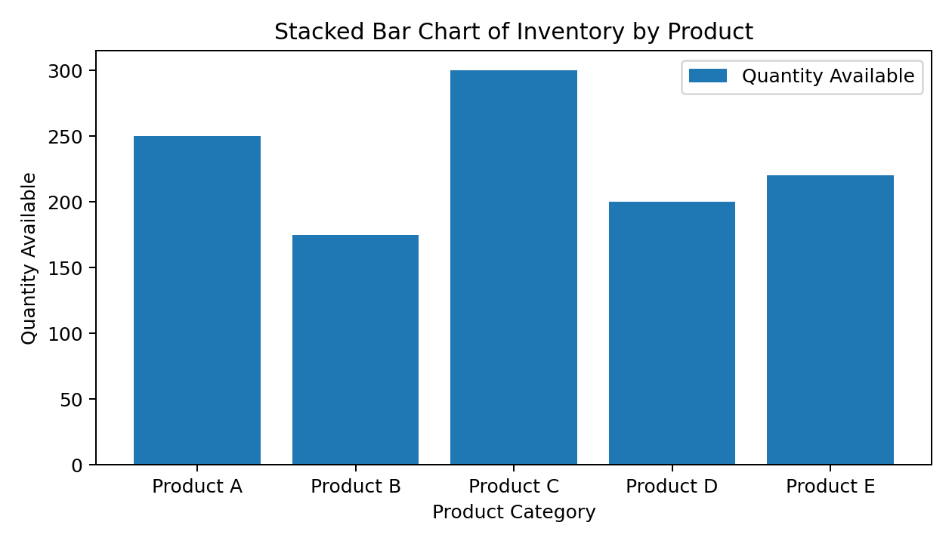
Finding: Product C has the largest stock level, while Product B has the smallest. Since there are no multiple category segments in the supplied data, this chart is a basic single-segment stacked bar chart. To compare different product categories within each product, category-wise quantity data would be required.

3. Scatter Plot: Product Price and Quantity Available
A scatter plot can be used to study whether product price is related to the quantity available. However, the supplied dataset does not include product prices. For demonstration only, illustrative prices have been used: Product A = 20, Product B = 15, Product C = 25, Product D = 18, and Product E = 22. These prices are examples and are not part of the original dataset.
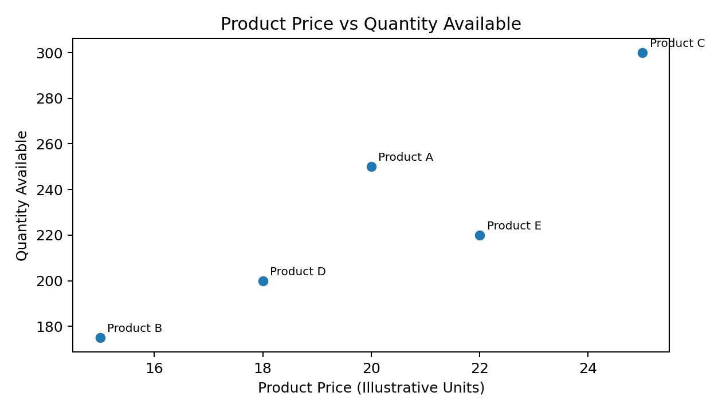
Finding: In this illustrative example, the points do not show a clear relationship between price and quantity. For example, Product C has the highest illustrative price and the highest quantity, while Product B has the lowest illustrative price and the lowest quantity. Since the prices are assumed, no reliable conclusion can be drawn from this plot. Actual prices are needed for a valid analysis.

4. Tableau Dashboard with Interactive Charts
A Tableau dashboard can combine the bar chart and stacked bar chart on one screen so that users can compare stock levels easily.
Steps to create the dashboard:
- Open Tableau and connect to the Product Inventory dataset in Excel or CSV format.
- Check that Product ID and Product Name are dimensions, and Quantity Available is a numeric measure.
- Create a bar chart by dragging Product Name to Columns and Quantity Available to Rows. Turn on mark labels and add axis titles.
- Create a stacked bar chart. Use a real product category field and place it on Color, with Quantity Available on Rows. If the dataset has no category field, add one before building a true category-wise stacked chart.
- Create a new Dashboard and drag both worksheets onto it.
- Add filters such as Product Name or Product ID, and apply them to both worksheets where appropriate.
- Add a dashboard title, legends, and tooltips so users can view exact quantities by selecting or hovering over bars.
- Save the workbook as a Tableau Packaged Workbook (.twbx) if it must be shared with the dataset.
Expected result: Users can compare inventory quantities, filter products, and view exact values interactively. The dashboard becomes more informative when product category and actual product price fields are included in the dataset.

